**GUJARAT TECHNOLOGICAL UNIVERSITY**

Chandkheda, Ahmedabad. Affiliated

 

Government Engineering College

Bhavnagar

# A PROJECT ON

**Student progress analysis and strategy**

B.E., SEMESTER-3

# INFORMATION TECHNOLOGY

Submitted By:-

1. CHIRAG CHAVDA (190210116013)
2. KUKADIYA AKHIL (190210116033)
3. KAJALIYA CHARCHIL (170210116025)
4. SONAGARA SAGAR (190210116075)

PROJECT GUIDE H.O.D

Prof. NISHIDH CHAVDA Prof. V.G. Patel

ACADEMICE YEAR

(2020-21)

Government Engineering College

Bhavnagar

# CERTIFICATE

Date: 23-04-2021

This is to certify that the subject entitled " **Student progress analysis and strategy** " has been carried out by

**CHIRAG CHAVDA** under my guidance in fulfillment of the project of

Design Engineering – 2A in I.T. (3rd Semester) of Gujarat

Technological University, Ahmedabad during the academic year 2020-21

Guided by:-

## Prof**. NISHIDH CHAVDA**

Government Engineering College

Bhavnagar

# CERTIFICATE

Date: 23-04-2021

This is to certify that the subject entitled " **Student progress analysis and strategy** " has been carried out by

**KUKADIYA AKHIL** under my guidance in fulfillment of the project of Design Engineering – 2A in I.T. (3rd Semester) of Gujarat

Technological University, Ahmedabad during the academic year 2020-21

Guided by:-

## Prof**. NISHIDH CHAVDA**

Government Engineering College

Bhavnagar

# CERTIFICATE

Date: 23-04-2021

This is to certify that the subject entitled " **Student progress analysis and strategy** " has been carried out by

**KAJALIYA CHARCHIL** under my guidance in fulfillment of the project of Design Engineering – 2A in I.T. (3rd Semester) of Gujarat Technological University, Ahmedabad during the academic year 2020-21

Guided by:-

## Prof**. NISHIDH CHAVDA**

Government Engineering College

Bhavnagar

# CERTIFICATE

Date: 23-04-2021

This is to certify that the subject entitled " **Student progress analysis and strategy** " has been carried out by

**SONAGARA SAGA**R under my guidance in fulfillment of the project of Design Engineering – 2A in I.T. (3rd Semester) of Gujarat Technological University, Ahmedabad during the academic year 2020-21

Guided by:-

## Prof**. NISHIDH CHAVDA**

**Contents...**

1. Introduction
2. Mind Mapping/AEIOU Canvas
3. Empathy mapping canvas
4. Ideation canvas
5. Product design
6. Prototype
7. LNM canvas
8. Feedback

1. Introduction:

* Our project name: Student Progress analysis and strategy
* This project will improveing educational skill of student and helps to know the lavel of his/her progress.
* It is use to determine the strategy of student and it is very easy for given marks and grad to student by faculty.
* It will helping to parents for checking their child’s progress…

## 2.Mind Mapping / AEIOU Canvas

* Mind map is another way to represent infprmation. It consists of creating a graphical word arborescence from a central topic.
* In mind mapping canvas we have to put all that things which we want to do in our project specifically.
* Here in picture we saw that mind mapping canvas.

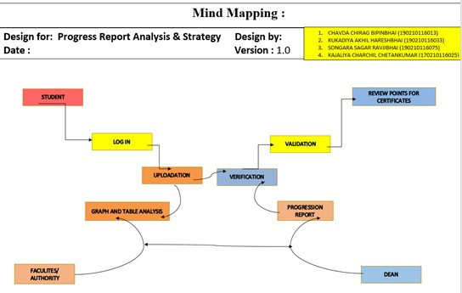

AEIOU stands for 5 elements to be coded: Activity, Environment, Interaction, Object, and User.

* **Activities** are goal-directed sets of actions—paths towards things people want to accomplish. We note that which activity you can preforms in our app.
* **Environments** include the entire arena where activities take place. We note that in which environment our project bing used.
* **Interactions** are between a person and someone or something else; they are the building blocks of activities.
* **Objects** are building blocks of the environment, key elements sometimes put to complex or unintended uses (thus changing their function, meaning and context).
* **Users** are the people whose behaviours, preferences, and needs are being observed. In this section we mention that for whom our project bing usefull.
* 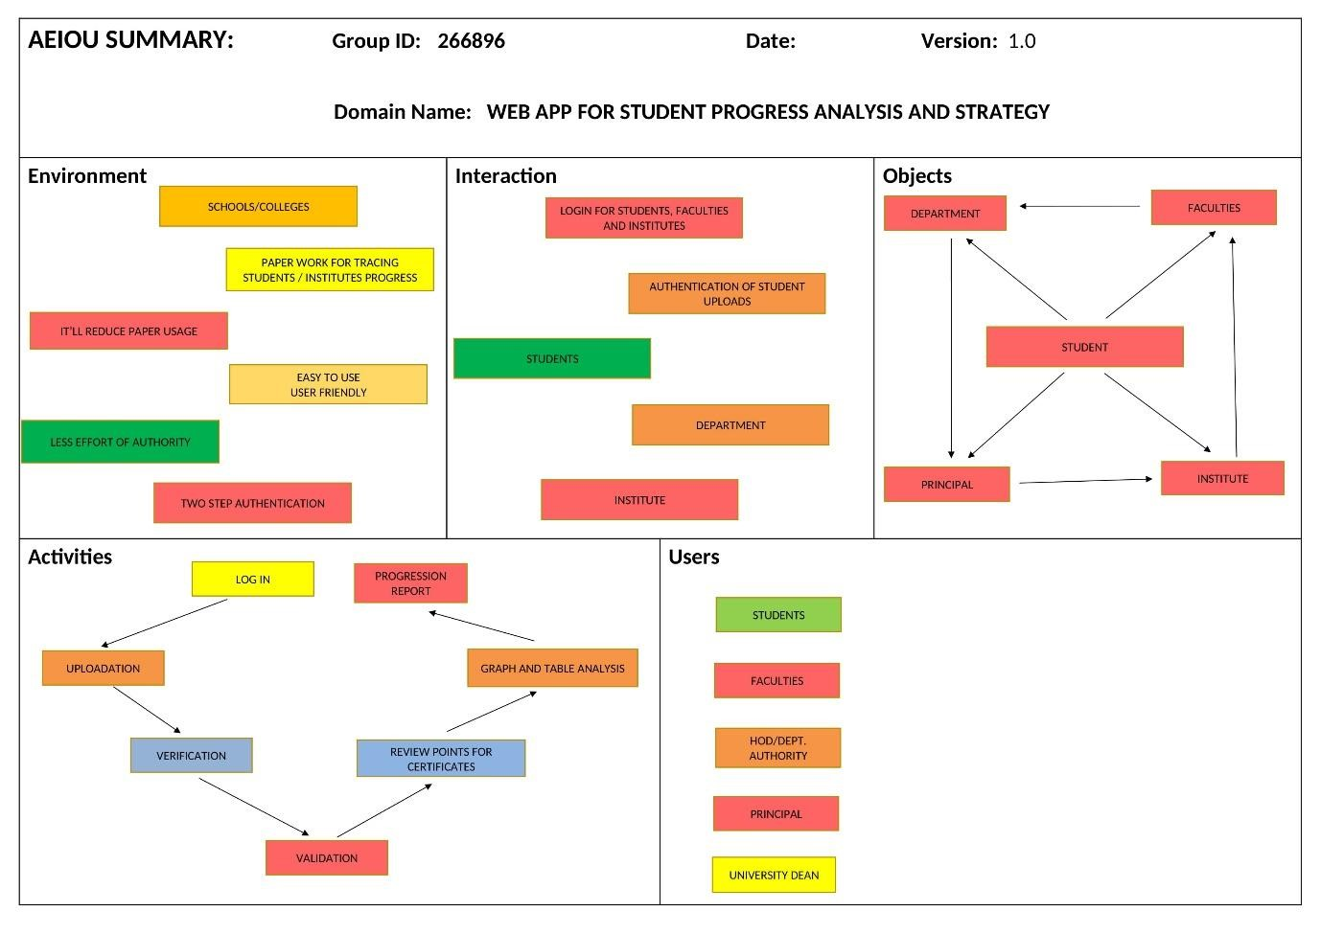

### AEIOU CANVAS

3.Empathy Canvas:

* An empathy map is a collaborative visualization used to articulate what we know about a particular type of user. It externalizes knowledge about users in order to 1) create a shared understanding of user needs, and 2) aid in decision making.
* Empathy Map is a tool that helps describe aspects of a user's experience, needs and pain points
* At this stage we will discover & learn the emotional aspect of our user. This stage will involve use of empathy map...

o **empathies** : understand your user o List user activities

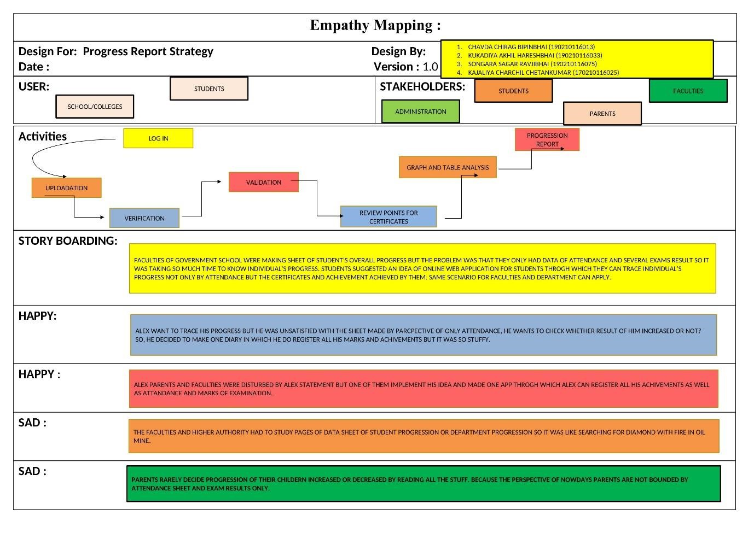

**Empathy mapping canavas**

## 4.Ideation Canvas

An ideation canvas is a rough whiteboard where ideas can be stretched into any limits or dimensions. Ideation session is not aimed at finding solutions to the defined problem But to define the best possible problem and stretch out its possible scope. The field is set and the overall agenda is to build the clones of the ideas and pivot them throughout the canvas so as to discover new possibilities.

• List user Activities will interact with the customers. Giving optimal solution.

➢ People who can take the benefit or, who (user & developer) are mentioned in this project.

* **People**: - Student, faculty ,HOD, Institutes ,Parents
* **Activities**:Uploads the data of student, verifications of documents, distribute certificates ,we analyse the progress of studentand make a report.

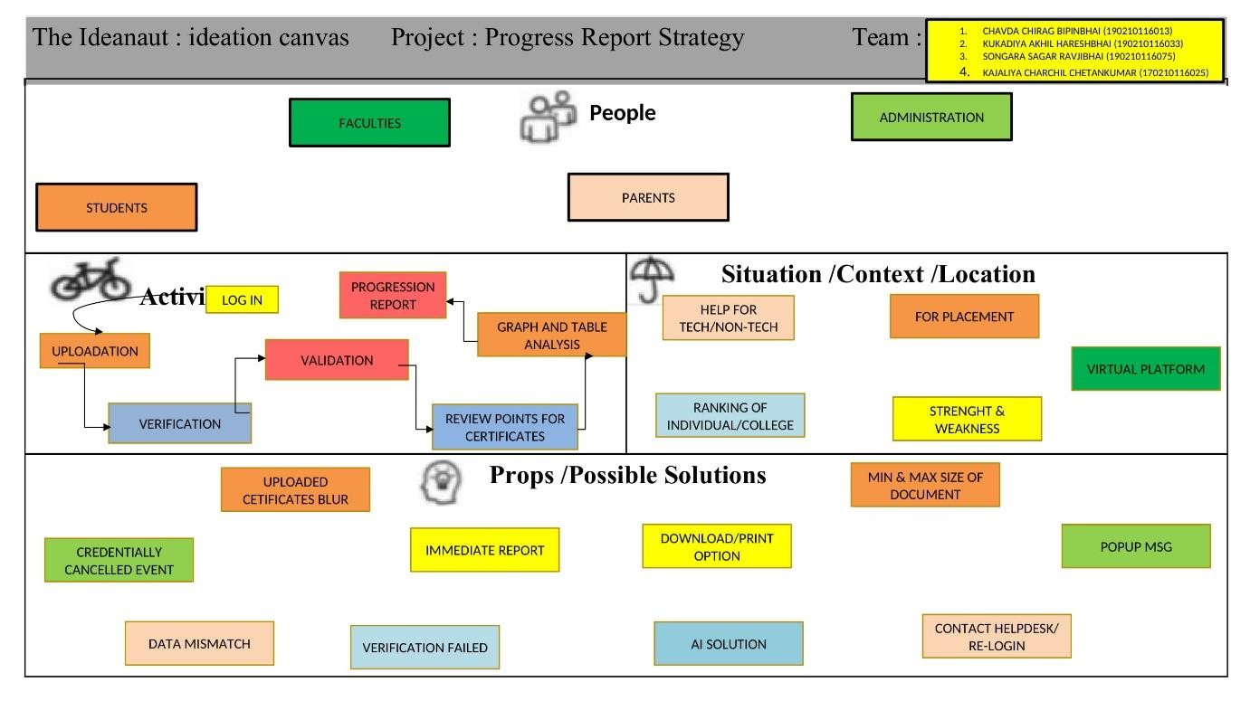

## **5.**Product Development

Product development canvas can give you insights to these problems when creating a product, factors such as , product experience , Purpose , People , product functions, product features, and components.

A product development canvas is the ground where in the best possible ideas after the ideation session are pitched and nurtured to develop.

* **People & purpose** :-student faculty, parents are use this project for their different purpose.
* **Product/service experience**:- reducr paper work, less effort, least or no cost, less time consuming.

**Describing user feelings**:- It is very useful ot get student progress for faculty as well as parents.

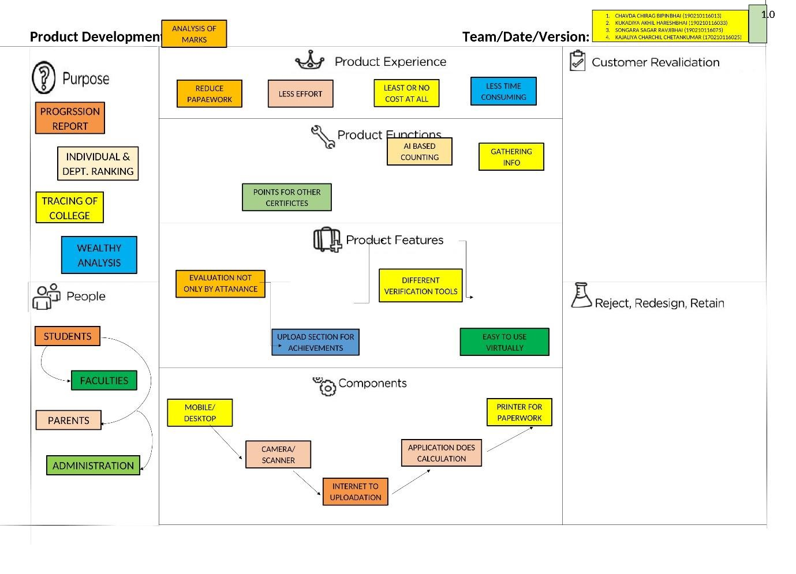

**Product development canvas**

**6. Prototype**

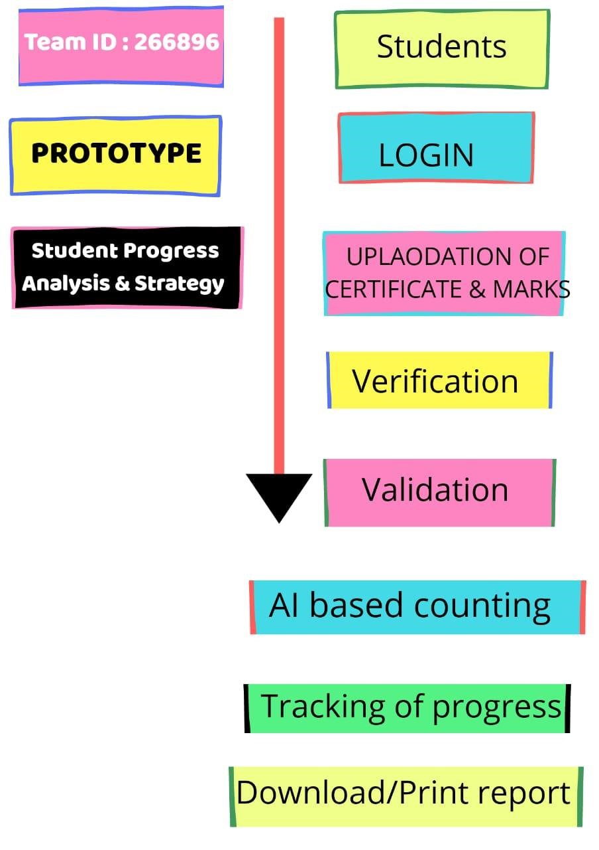

1. **LNM (**Learning Needs Matrix **)canvas**

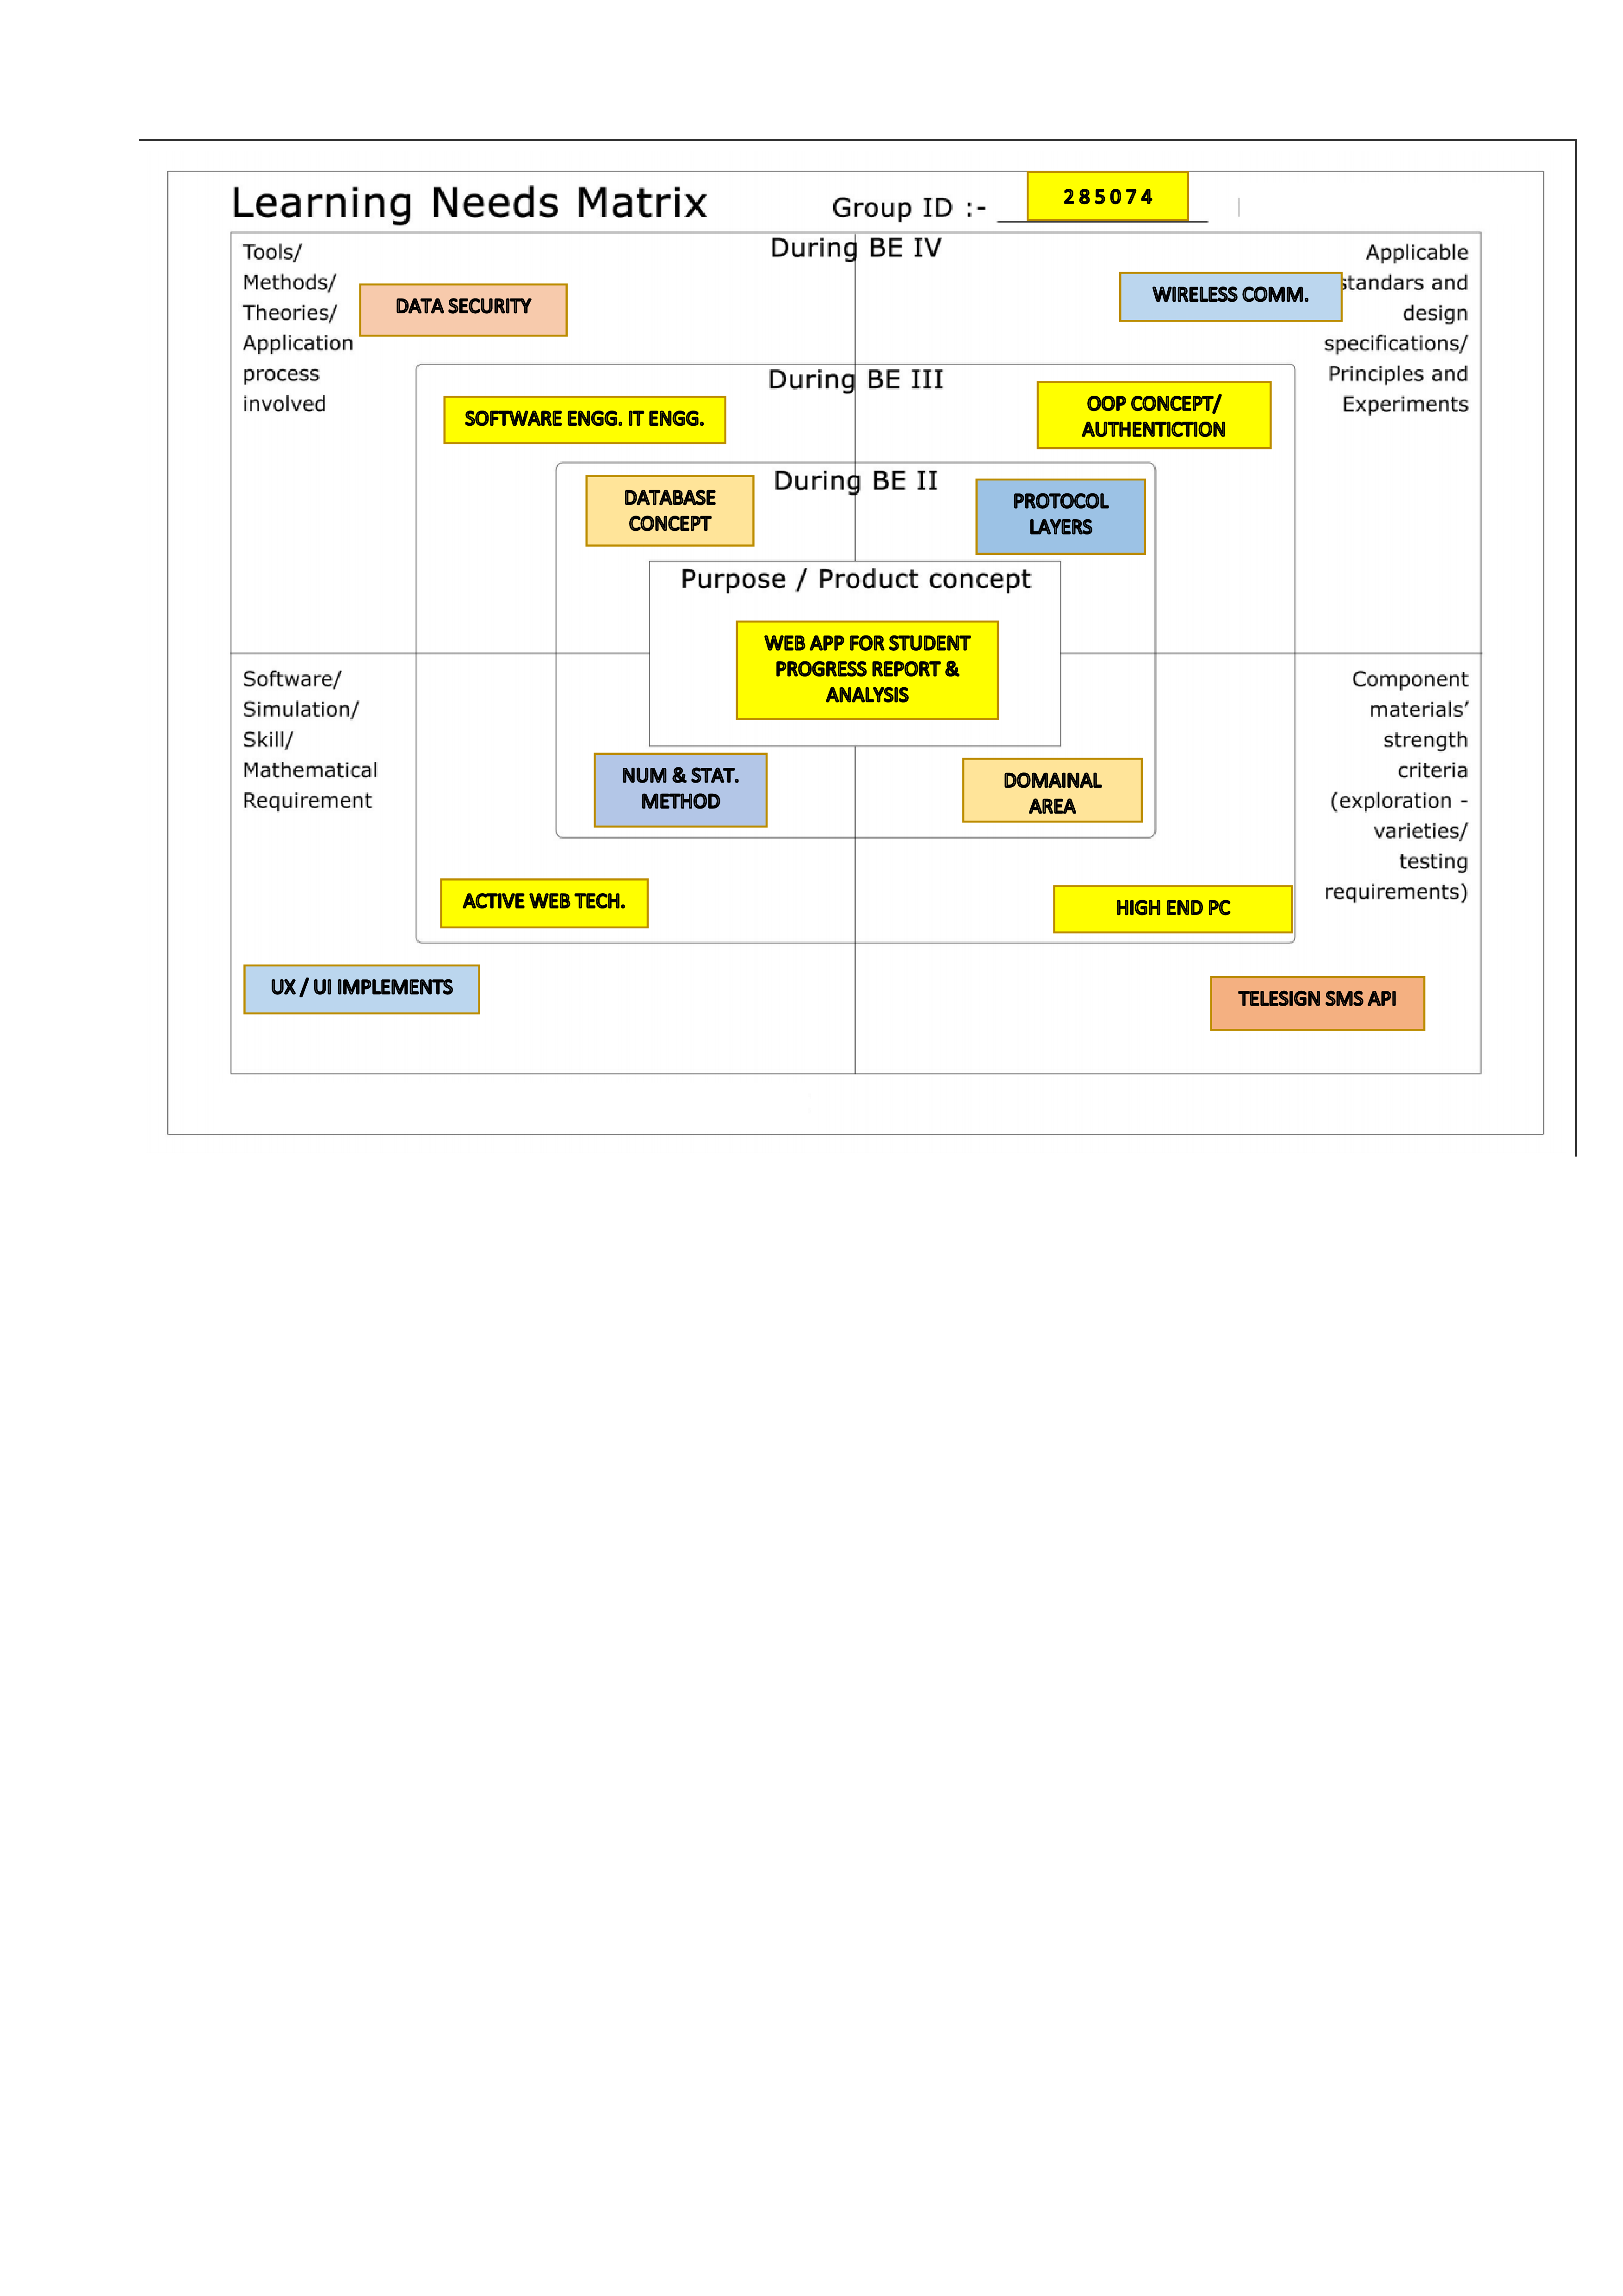

The purpose of LNM is to identify the requirements of learning among the team members. While a new product/process is under development based on a unique idea (to reduce the level of difficulty faced by a user), the team members need to learn and explore a lot of new skills and documents, methods and guidelines.

**8.Feedback:**

* By using this web app faculty or administers observe their students progress and they can easily make a strategy to improve it.
* Parents can know their children’s attendances, marks or grad easily.
* Student can compare their progress to another student.
* By using this web app student can easily submit their work or project.
* Faculty can give important notice through this web app easily.